**Classifying Buildings post Hurricane**

Team members: *Chaitanya Agarwal, Chinmay Jain, Gurushankar K, N Santosh Gokul*

**Team name with members**

**Model**

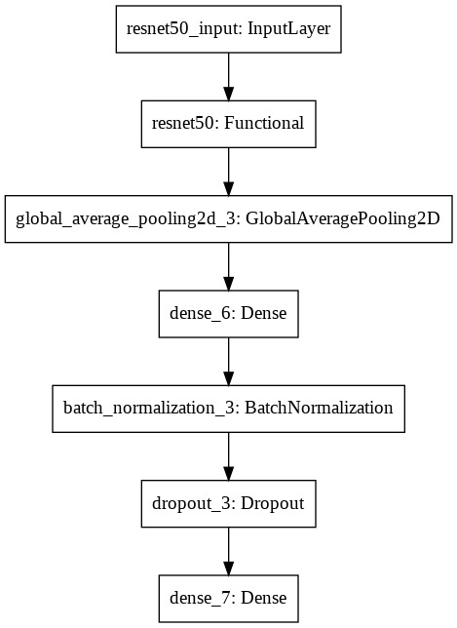

**Conclusion**

Tried different preprocessing techniques to tackle the blurred images and observed simple sharpening worked the best.

Experimented with different SOTA architectures and training configurations; found that ResNet50 with two stage training worked the best.

Visualized the attention of the trained models using GradCAM over the inputs and realized that the model is focusing on the logical regions of the image.

**Future work**

1. Super-resolution using autoencoders.
2. Trying out other de-blurring techniques.
3. Generate more data using GANs.
4. Ensemble of different SOTAs.
5. Extend the model to other natural disasters.

**Motivation and About the Project**

The project enables the government all over the world to switch from an inefficient current process of driving down to the affected area and identify the relief required area, rather capturing the satellite image of the calamity affected area and process through the neural network model to identify where immediate government attention is required.

**References**

* <https://www.tensorflow.org/api_docs/python>
* [https://github.com/keisen/tf-keras-vis/blob/master/examples/attentions.ipynb](https://meet.google.com/linkredirect?authuser=0&dest=https%3A%2F%2Fgithub.com%2Fkeisen%2Ftf-keras-vis%2Fblob%2Fmaster%2Fexamples%2Fattentions.ipynb)
* <https://arxiv.org/pdf/1512.03385>

**Results**

**Classification report of Balanced test data:**

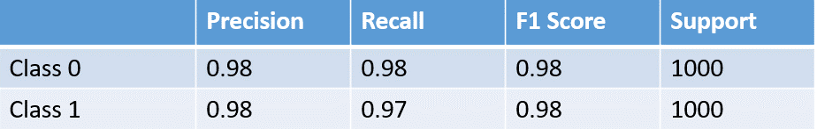

**Classification report of Unbalanced test data:**

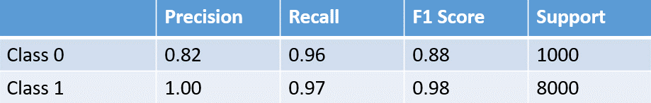

*Class 0 - Undamaged Class 1 - Damaged*

**Data and Labels**

The dataset is collected from "Geo-satellite sensor" and "Geo Bigdata".

There are two target labels in the dataset:

* Class 0 - Undamaged
* Class 1 - Damaged